Mechanical assembly of oligomers and polymers on elastomeric substrates

Jan Genzer
Department of Chemical Engineering, North Carolina State University, Raleigh, NC 27695-7905

It is well known that the surface properties of materials, such as wetting and lubrication, can be successfully tailored by terminally attaching various organic modifiers. Typically, self-assembled monolayers (SAM) are utilized to prepare chemically and structurally well-defined surfaces. Because SAMs are formed through self-assembly the packing density of the SAM is set by the interplay between the chemical and structural nature of the SAM molecules and the means of their attachment to the substrate. In some situations, the fixed packing density of the SAMs limits the stability of the monolayer and its resistance to surface reconstruction.
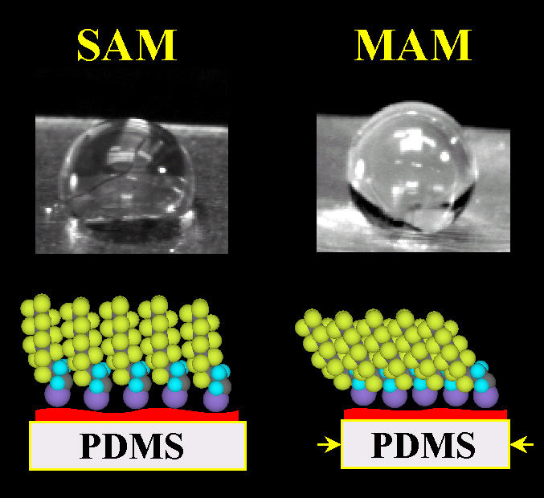
We have recently developed a novel method of tailoring the grafting density of end-anchored molecules on substrates. The technique is based on combining: 1) the grafting reaction between chlorosilane moieties and surface hydroxyl functionalities, and 2) mechanical manipulation of the surface grafting points. An elastomeric network film is stretched (by Δx) and treated with UV/ozone to produce the surface hydroxyl groups. Chlorosilanes are deposited from vapor and form a SAM. The strain is subsequently released from the substrate, which returns to its original size, causing the grafted molecules to form a densely organized ”mechanically assembled monoloayer” (MAM). As a proof of concept we created MAMs from semifluorinated molecules (SF-MAMs). Our experiments reveal that the SF-MAM surfaces are super-hydrophobic; the water contact angle increases with increasing Δx and culminates at a value of 135º for Δx ≈ 80%. These SF-MAMs are highly resistant to surface reconstruction - while SF-SAMs on non-stretched surfaces reconstructed only after several hours, the surfaces of SF-MAMs immersed in water for a week (followed by a subsequent storage under ambient laboratory conditions for 6 months) stayed virtually unmodified.
Water droplets spreading on SF-SAM surfaces (left) and those on the SF-MAM surfaces (right) stretched by Δx = 70% with respect to their original length prior to the SF molecules deposition.
We have also extended the MAM technology to produce polymer brushes with variable grafting densities using MAPA (=”mechanically assisted polymer assembly”). MAPA is based on: 1) chemically attaching polymerization initiators to the surface of an elastomeric network that has been previously stretched by a certain length, Δx, and 2) growing end-anchored macromolecules using surface initiated (“grafting from”) atom transfer living radical polymerization. After the polymerization, the strain is removed from the substrate and the grafted macromolecules stretch away form the substrate forming a dense polymer brush. We demonstrate the feasibility of MAPA by preparing high-density polymer brushes of poly(acryl amide), PAAm. We show that, as expected, the grafting density of the PAAm brushes can be increased by increasing Δx.
Finally, we will discuss how the MAM and MAPA technologies can be utilized to prepare molecular gradients with tailorable surface properties. We will show that a good control over the chemistry, gradient steepness, and gradient position on the substrate, can be achieved.

Supported through the NSF CAREER and Camille-Dreyfus Teacher-Scholar awards.
J. Genzer and K. Efimenko, Science 290, 2130 (2000).
T. Wu, K. Efimenko and J. Genzer, Macromolecules 34, 684 (2001).
K. Efimenko and J. Genzer, Advanced Materials, in press (2001).

